**Data Analyst in Power BI Data-Camp 2025**

**Section 7: Data Modelling in Power BI**

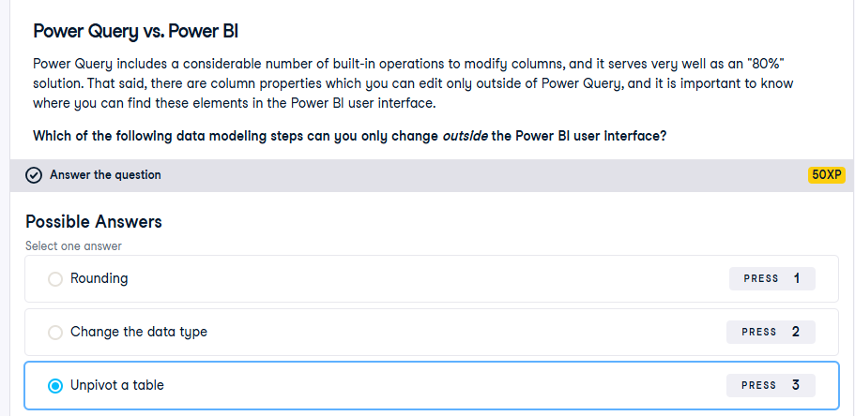

**Section 1 Defining Tables**

**Exercise 1.1** 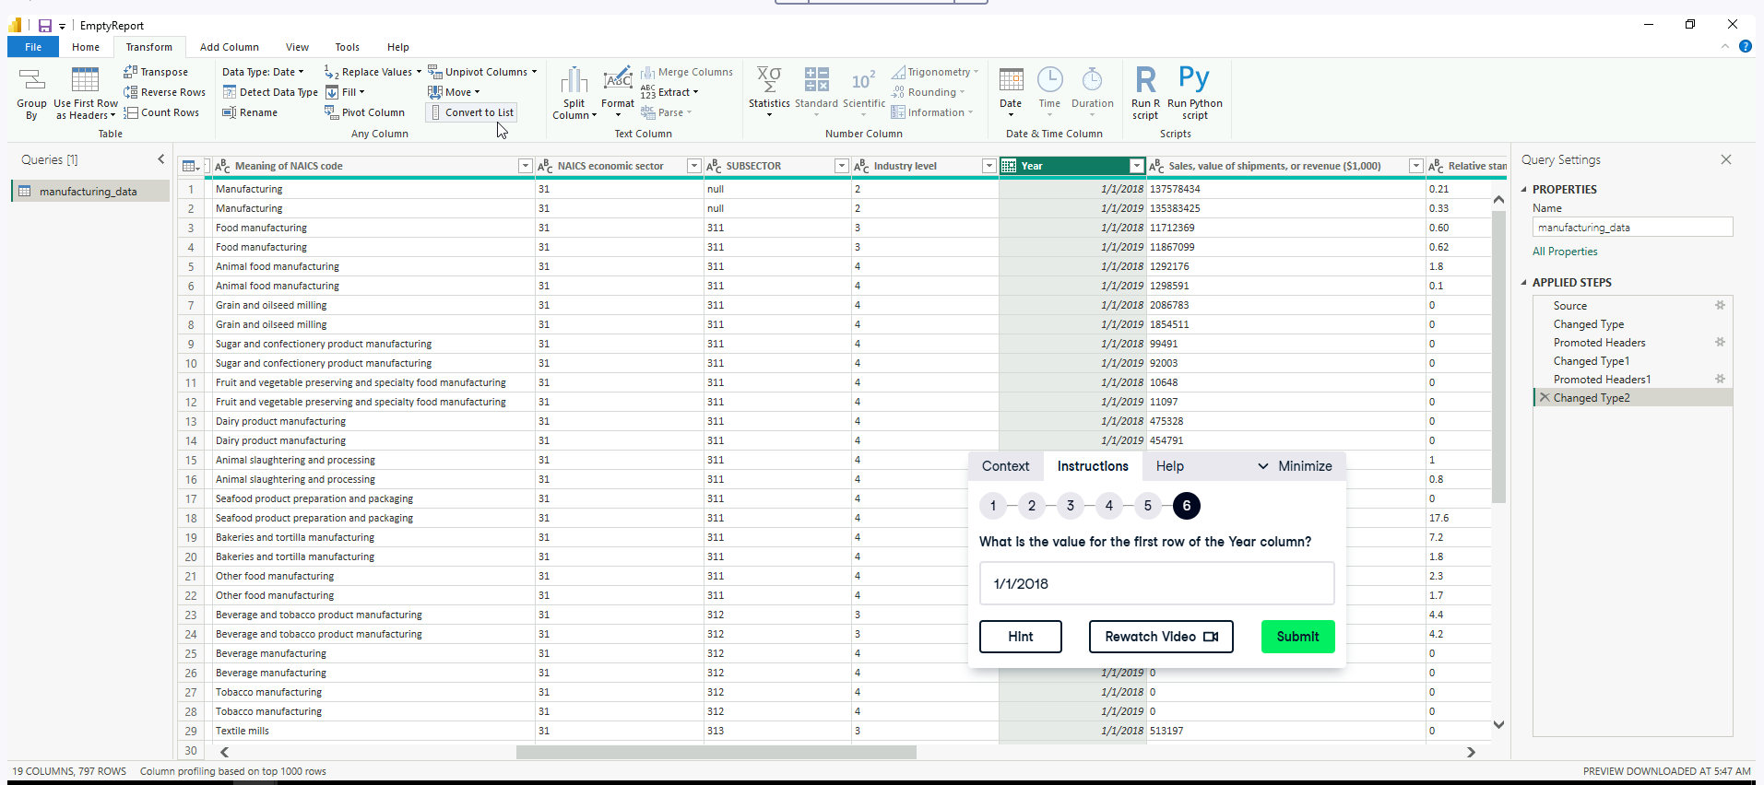

**Exercise 1.2**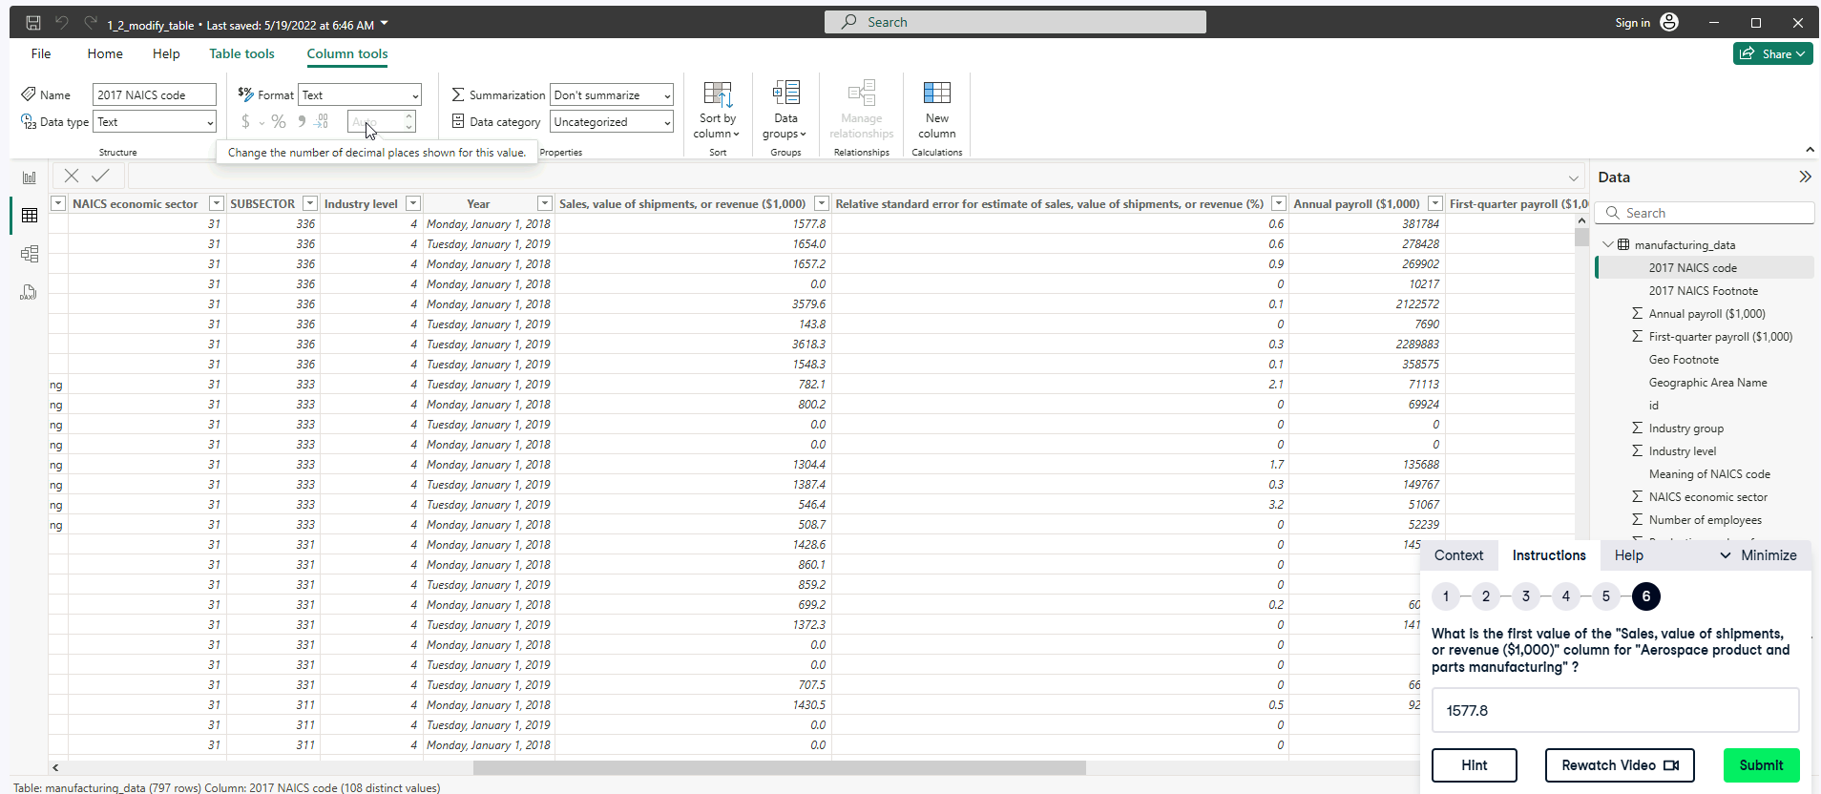

**Exercise 1.3**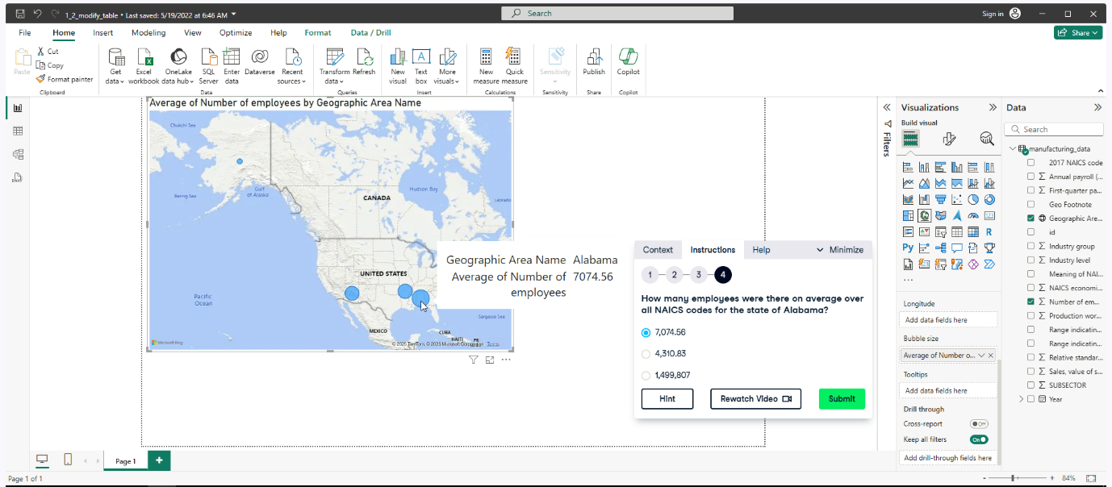

**Exercise 1.4**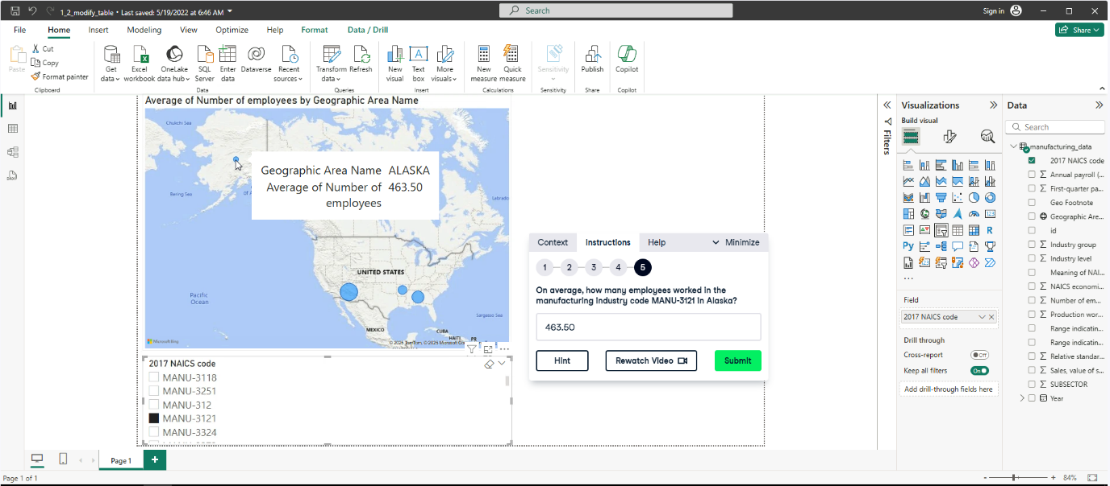

**Shaping Tables**

**Exercise 2.2**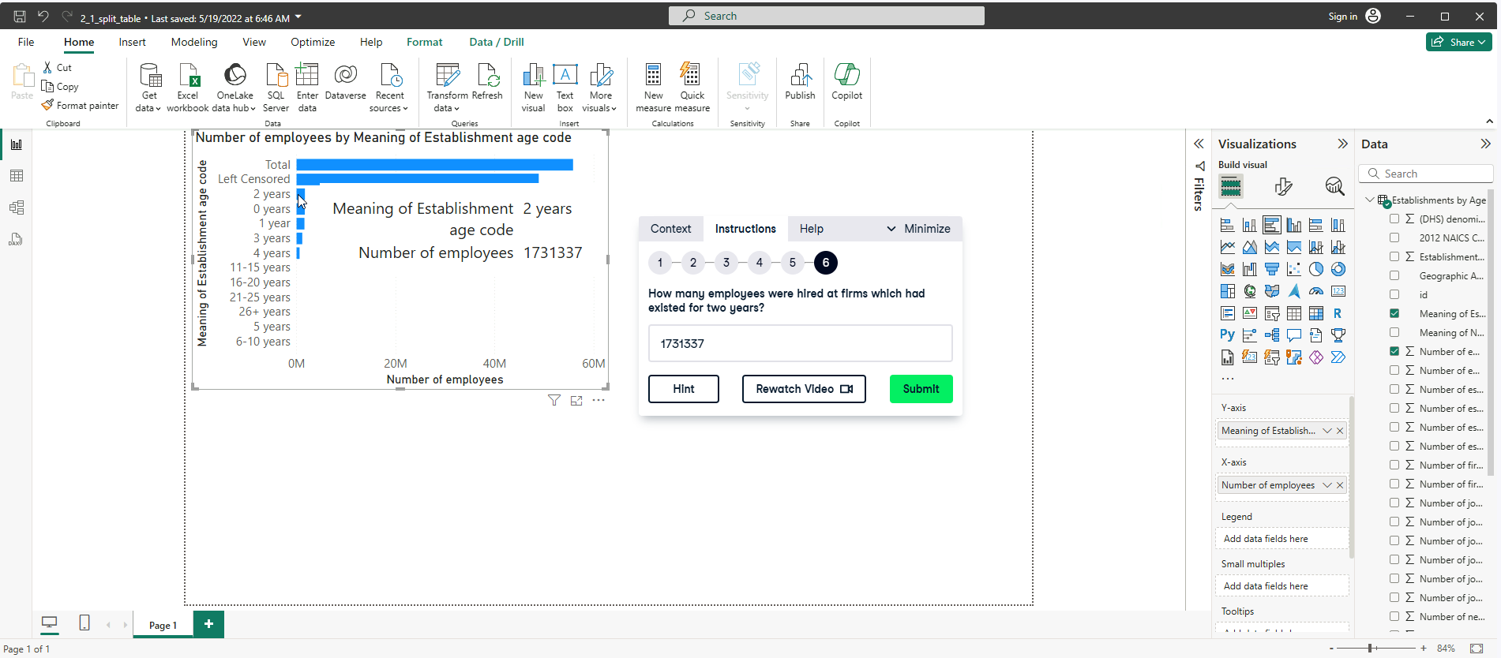

**Exercise 2.3**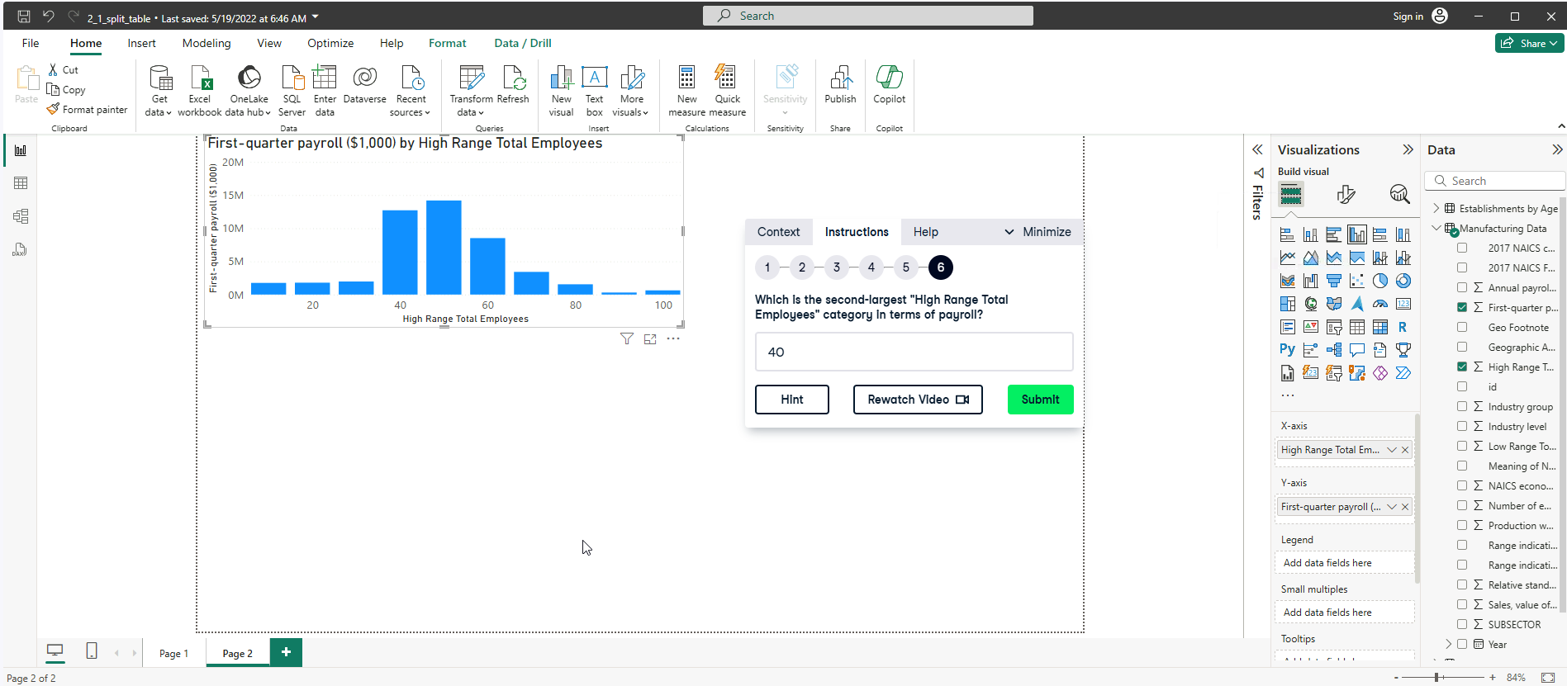

**Dimensional Modelling**

In Power BI (and data warehousing in general):

* Facts are quantitative data — the measurable values you want to analyze (e.g. sales, profit, quantity).
* Dimensions are descriptive data — the categories or context for the facts (e.g. date, product, region).

NOTE: Facts answer **"how much?"**, dimensions answer **"who, what, when, where?"**.

**Exercise 3.1**

**Exercise 3.2**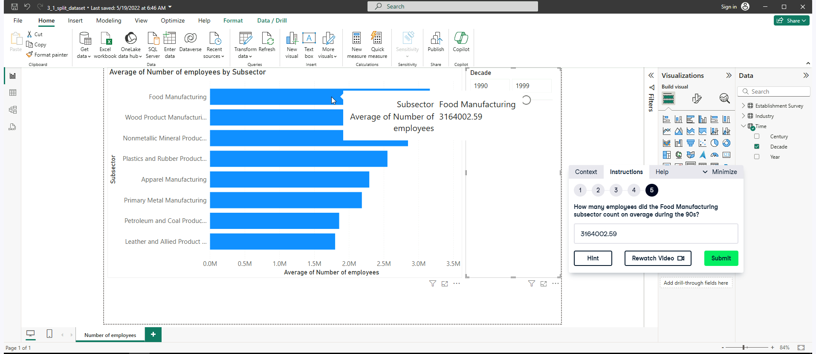

**Exercise 3.3**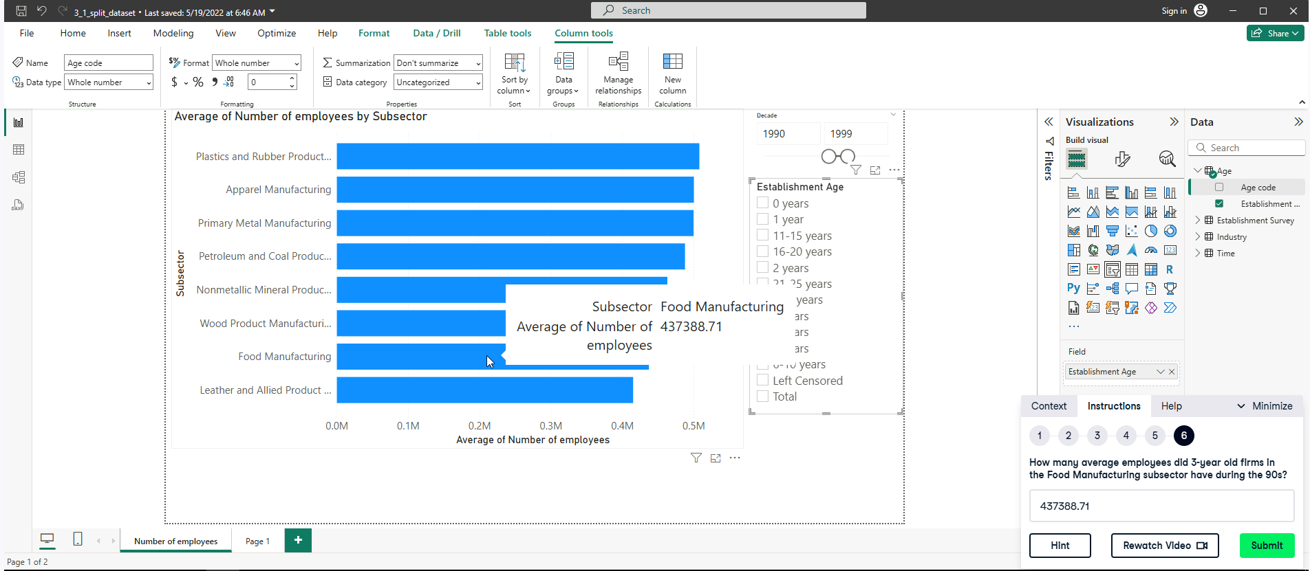

**Star and Snowflake schemas**

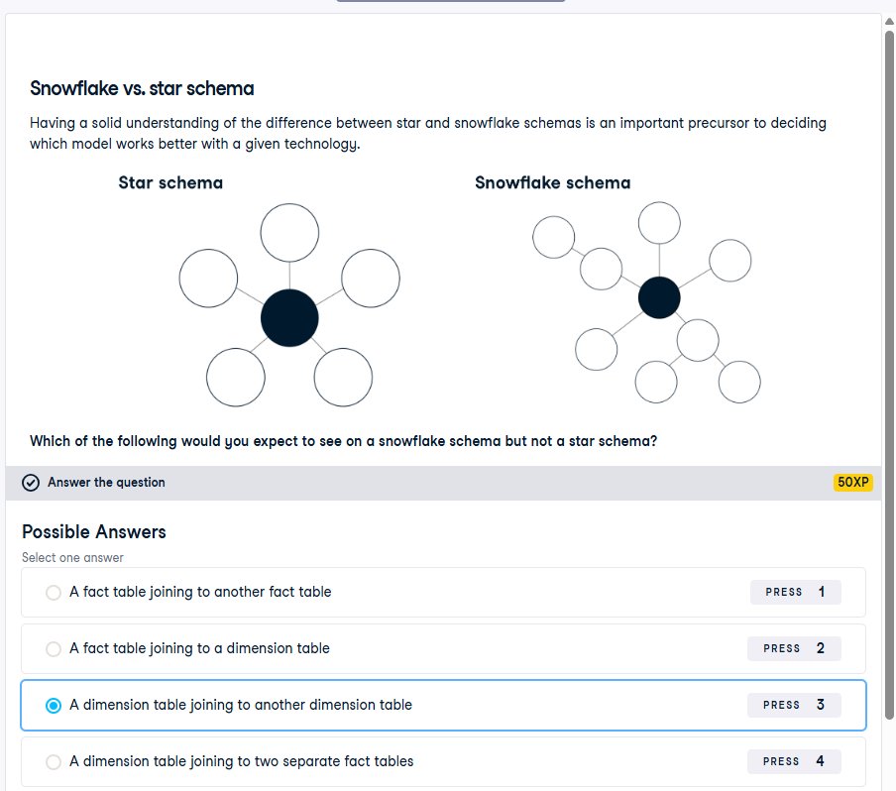

**Exercise 4.1**

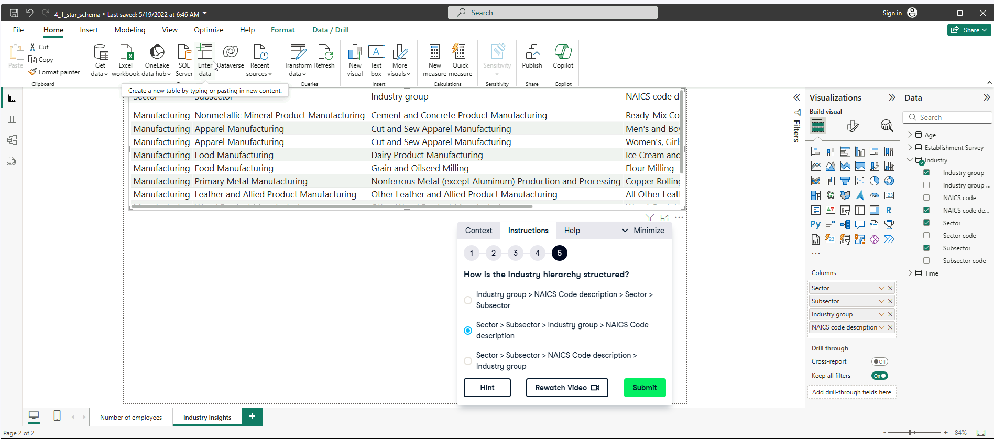

**Exercise 4.2**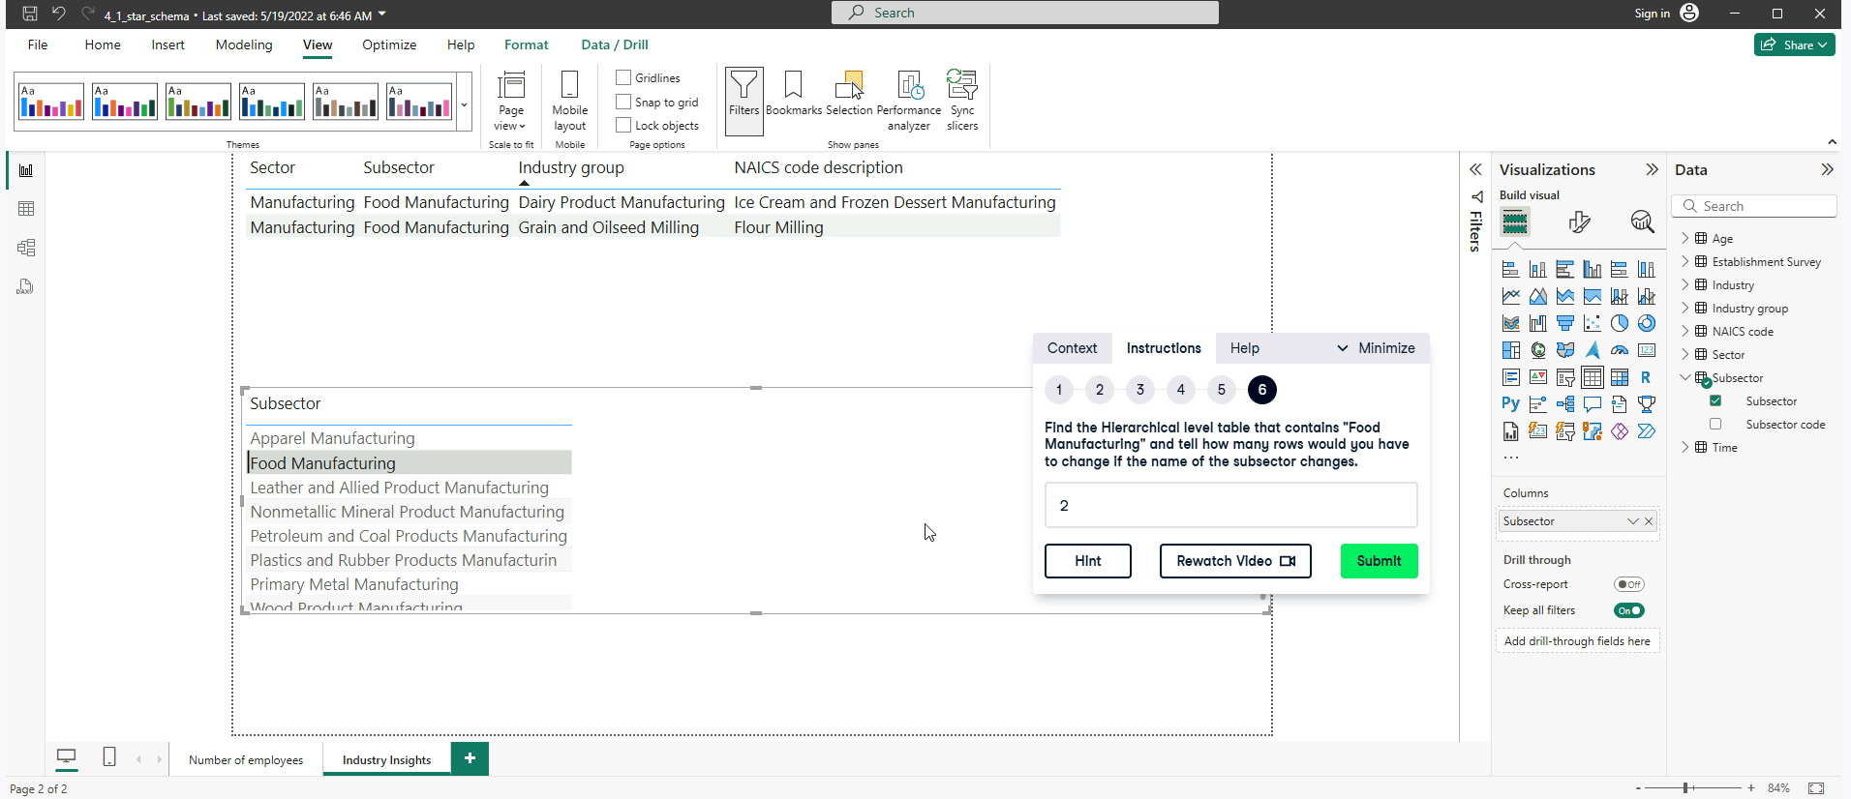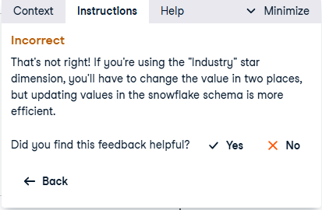

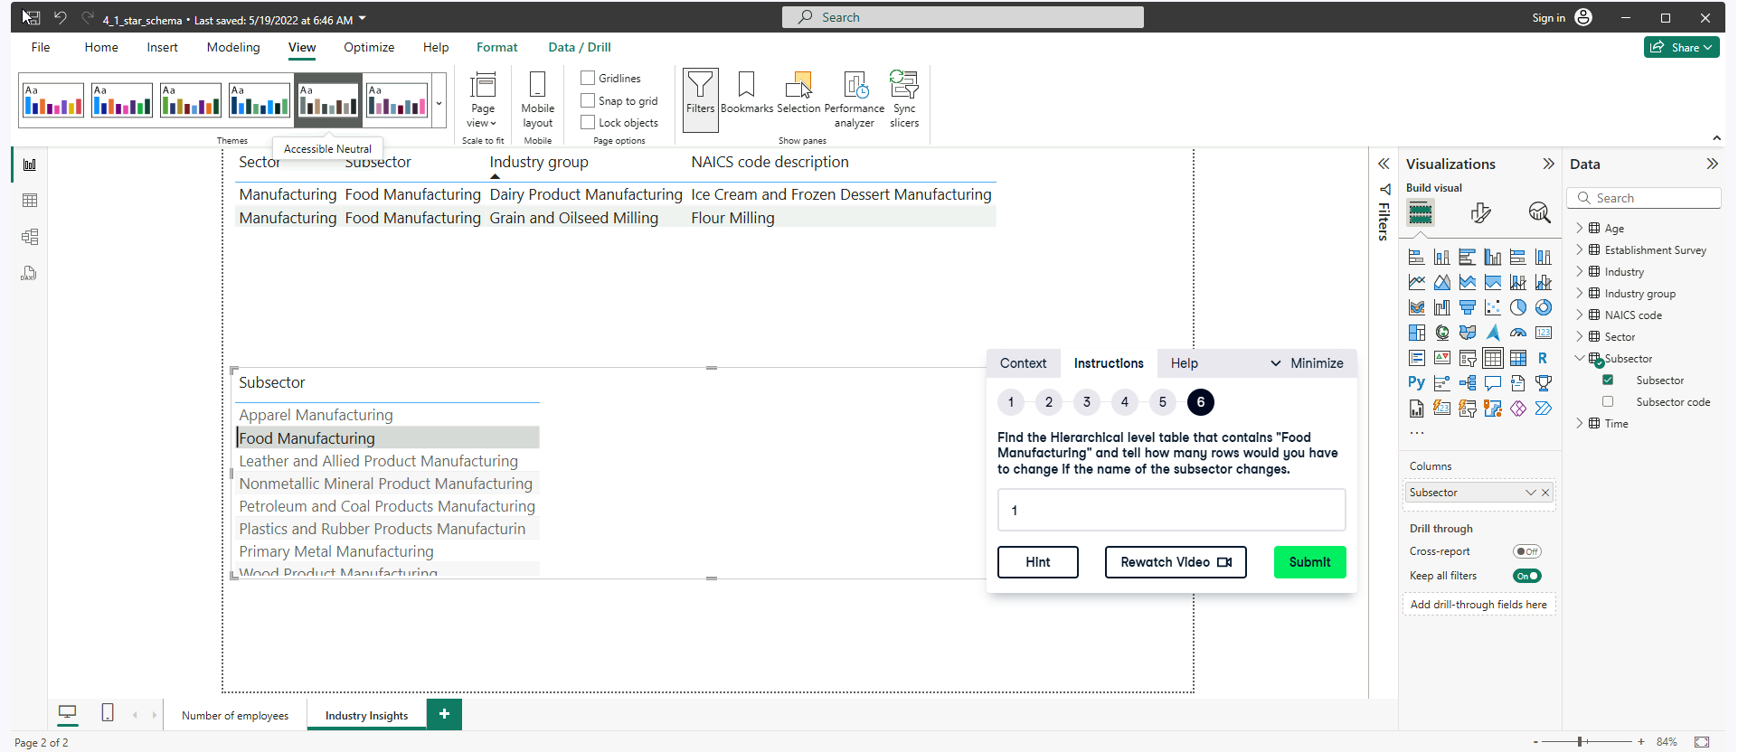

**Exercise 4.3**